Intelligent Customer Retention: Using Machine Learning for Enhanced Prediction of Telecom Customer Churn

1. **INTRODUCTION**
   1. **Overview:**

**Problem Definition:**

Customer churn is a major concern for telecom companies. Losing customers can lead to a significant loss of revenue and market share. To address this issue, telecom companies can use machine learning and predictive analytics to identify customers who are at risk of churning.



**Task 1: Define Problem / Problem Understanding.**

(i)Specify the business problem

(ii)Business requirements

(iii)Literature Survey

(iv)Social or business impact

**Specify the Business problem:**

Customer churn means Customer leaving from their companies. It is the biggest problem for companies. Especially in telecom field, Customer churn is the major problem.

**▪ If continuing the customer churn state,**

✓ The companies has no profit.

✓ And no partnership.

So Customer churn is the most important for companies. If the customer has low State, the didn’t competite with any Other companies.

**▪ To improve the churn state,**

o Use more Marketing Strategies.

o Improve the behaviour of the customer.

**▪ Why customer churn?**

✓ Better price offers

✓ Bad service Experience

✓ Customer’s personal situation

From customer side , if the companies not suitable for them they will Leave and move to Next companies with better plan . For happening this not avoidable, but keep this to minimal level.

Business Requirements:

In machine learning, the business requirements is used to predict Whether the Customer will churn or not.

**There are two methods to Shortlist the Business requirements,**

✓ False positives ( Definitely the Customer will churn)

✓ False negatives (Only thought the customer will Churn)

Provide a better Model for making better decision to gain profit.

Literature Survey:

Mostly all are digitalization, So banking sector also use ML to apply loans and investigate their information.

✓ Apart from this, the ML can also calculate to take care of the issues of leaving the customer depending on their Companies.

✓ Telecom companies use the customer churn as a key business metrics to predict the amount of customer churn.

Social or Business impact:

* 1. ✓ Social impact: Our proposed model can help to improve the customer experience and service Quality. And also help to have New Customers.

✓ Business impact: This is use to generate revenue using to Sold a product to the telecom companies. It is based on Subscription method.

**Task 2: Data Collection & Preparation**

(i). Collect the Data Set

(ii). Importing the libraries

(iii). Read the Data set

(iv). Data Preparation

1. **Collect the Data Set:**

Download the data set from kaggle.com

1. **Importing the libraries:**

Importing the necessary libraries like .. ( Pandas as pd ), ( Numpy as np ),

( Matplotlib.pyplot as plt), ( Seaborn as sns ).

1. Read the Dataset:

Our dataset format might be in .csv We can read the dataset with the help of pandas. Functions are called read csv()

**Data Preparation:**

The downloaded dataset is not suitable for training the machine learning model. Need to Dataset properly clean. 3 types of activities:

(i). Handling missing values

(ii). Handling categorical data

(iii). Handling imbalanced data

**(i):** To find the shape of our data, the df.shape method is used.

**(ii):** We must convert categorical Data to integer encoding or binary encoding. Label into numeric form convert machine readable form. Label encoding refers to converting label into numeric form convert machine readable form.

**(iii):** Which need to the performance are classification model. Balancing data using SMOTE Method.

**Task 3: Exploratory Data Analysis:**

(i). Descriptive Statistical

(ii). Visual Analysis

1. Univariate Analysis

2) Bivariate Analysis

3) Multivariate Analysis

**(i) Descriptive Statistical**:

Descriptive analysis is to study the basic features of data with the statistical process.

**(ii) Visual Analysis**:

Visual analysis is the process of using visual representation. Such as chart, graph, explore and understand data. It is a way to quickly identified platform.

**1)Univariate Analysis:**

Univariate analysis is understanding with a single future. The seaborn package provides a wonderful function distplot and countplot.

**2)Bivariate Analysis**:

We can inter the analysis such as segment the gender column .

**3)Multivariate Analysis**:

Multivariate Analysis is to find the relation between multiple future we have used swarm plat from the seaborn package.

1)Heatmap.

2)Pairplot.

**Task 4: Model Building:**

We can Train the model using multiple Algorithms.

(i). Logistic Regression Model- LR

(ii). Decision Tree Model- DT

(iii). Random Forest Model-RF

(iv). KNN Model ( K-Nearest neighbours)

(v). SVM (Support vector machine)

**Training the model in multiple Algorithms**

We can train our data on different algorithms From this project we are applying five classification algorithms.

**(i)Logistic Regression model:**

Logistic regression estimates the probability of an event occurring dataset of independent

Variables.

**(ii)Decision tree model:**

Decision tree is created and train and test data are passed as the parameters.

**(iii)Random Forest Model:**

Created the train and test data are passes as parameters. Test data is predicted with predict(), saved in new variable.

**(iv)KNN model :**

Neighbour classifier algorithm is initialised training data is passed to the mode with. Fit() function

**(v)SVM model:**

“Support vector machine” (SVM) is a supervised machine learning algorithm can be used for both

Classification or regression challenges.

**Task 5: Testing the model:**

Once the model is trained, it needs to be evaluated. This involves testing the model on a separate dataset to measure its accuracy, precision, recall and f1-score.

**Task 6: Model Deployment:**

After the model is trained and tested, it is ready for deployment. The model can be deployed in various ways, including a web application. The model can be integrated with the bank's existing system to predict customer churn in real-time.

**1.2) Purpose:**

The bank customer churn predict model can help banks to identify customers who are at risk of churn and take appropriate actions to retain them. The model can also help banks to identify the factors that contribute to customer churn and take measures to address them. By implementing a customer churn predict model, banks can improve customer retention and maintain their revenue.

**2) Problem definition & Design Thinking:**

**Empathy Map:**

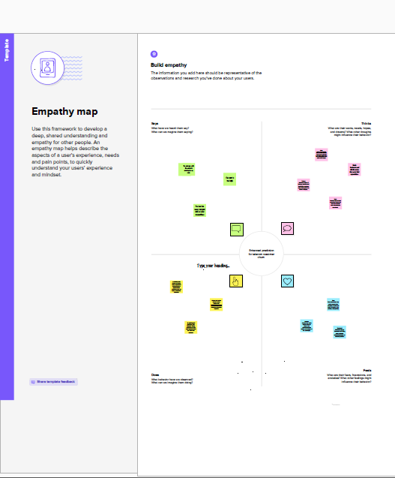

**3) RESULT:**

1. *The customer is Churn.*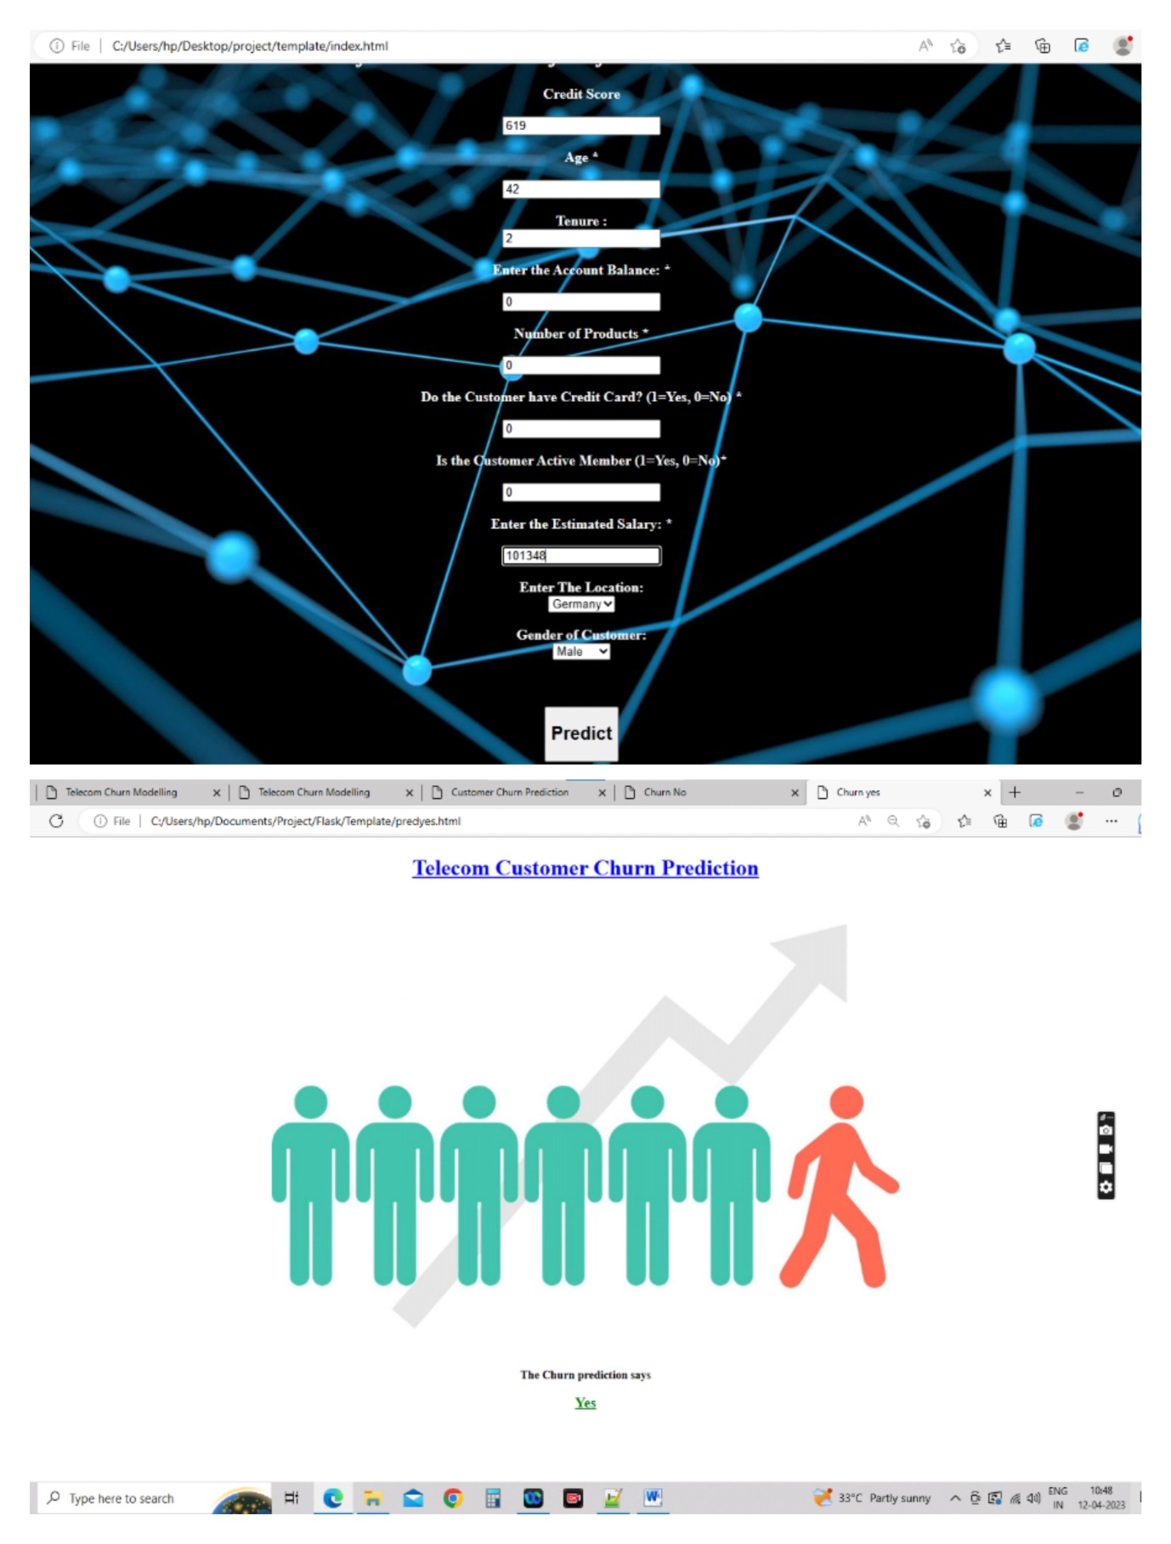
2. *The customer is not Churn.*

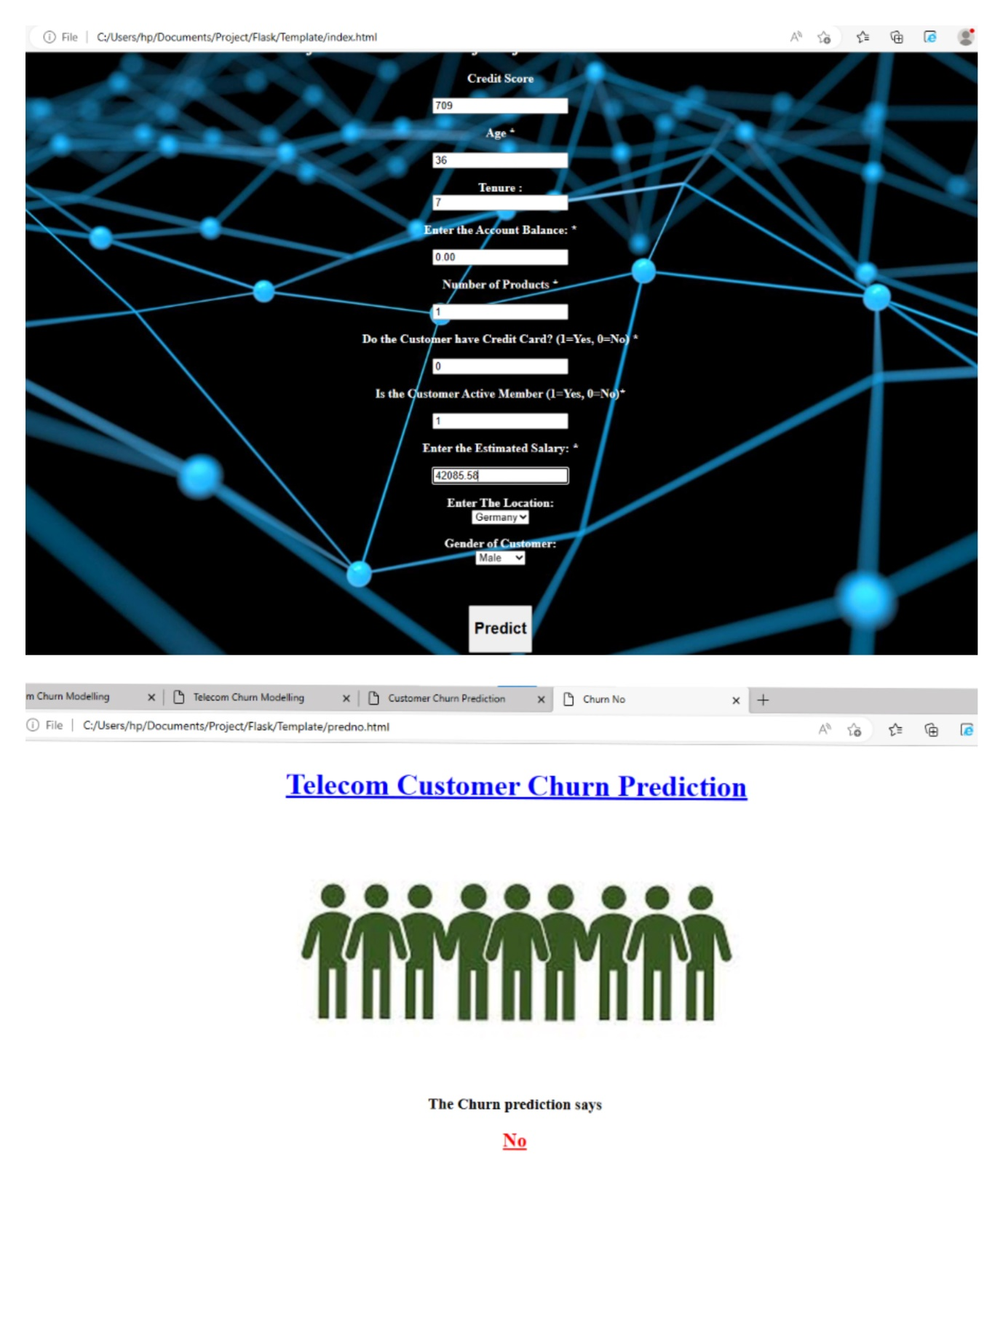

**4) ADVANTAGES & DISADVANTAGES:**

**Advantage:**

1. Identify at-risk Customers.

2. Identify methods to implement.

3. Improve the certain situation.

**Increased Profits:**

Upselling to Existing Customers is easier and more Cost-effective rather than selling to new ones.

**Avoid Losses:**

Retaining your Existing customers means stopping Customer churn, and can help you to prevent Revenue decreases or Opportunity for competitions.

**Disadvantage:**

1. Paying for staff training
2. The extra services offered, such as refreshments.
3. Higher wage costs from the extra time staff take to provide post- sales service.
4. Higher staff wages from hiring employees who are experts in customer service.
5. Lower your chances of growing your business.

**5) Applications:**

Suppose a bank wants to reduce its customer churn rate and retain more customers. To do this, the bank can use customer churn prediction to identify customers who are likely to leave and take steps to keep them.

The bank can begin my collecting data on customer behavior, such as transaction history, account balances, and credit scores. Using machine learning algorithms, the bank can analyze this data and identify patterns and trends that are indicative of customers who are at risk of leaving.

**6) Conclusion:**

Customer churn is a major concern for telecom companies. Losing customers can lead to a significant loss of revenue and market share. To address this issue, telecom companies can use machine learning and predictive analytics to identify customers who are at risk of churning. This documentation outlines the steps involved in building an intelligent customer retention system using machine learning.

**7) Future Scope:**

Telecom customer churn is a critical issue in the tlecom industry , and its expected to remain a major concern for service providers in the future. The future scope for telecom customer churn involves using advanced technologies and data analytics to reduce churn rates, retain existing customers, and acquire new ones.

One of the most promising technologies for reducing customer churn is artificial intelligence(AI) and machine learning(ML). BY leveraging the power of Al and ML ,telecom companies can analyse the amounts of data to identify customer behaviour patterns and predict which customers are most likely to churn. This information can then be used to develop targeted retention strategies to keep those customers happy.

**8) Appendix:**

**Source code:**

1. Ipynb file:

<https://drive.google.com/file/d/18iPYTkYtZOL09JOlYiZhOpOVfv4tpC6v/view?usp=drivesdk>

1. App.py :

<https://drive.google.com/file/d/18xa7LTyT3y60KyKrg444oJNi45uTNQOC/view?usp=drivesdk>